Fluidity Interview Assignment
Scalable Disk Utilization Monitoring for AWS EC2
Using Ansible and AWS-Native Services
Nitin Shet BS
Role Applied For: Solution Architect
Submission Date: 12 September 2026
Document Version: 2.0
Final design reflects the implemented proof-of-concept and clearly separates enterprise prerequisites from assignment-owned resources.

Executive Summary:
The objective of this solution is to provide centralized monitoring of disk utilization across EC2 instances in a multi-account AWS environment, enabling proactive detection of storage capacity issues before they impact application availability.
The solution leverages existing AWS-native services and minimizes operational overhead by using CloudFormation StackSets, AWS Systems Manager, CloudWatch Agent, and CloudWatch Cross-Account Observability.
Ansible remains part of the solution but is limited to:
- Bootstrapping SSM Agent on legacy or non-standard operating systems
- Ad-hoc disk audits and troubleshooting
This approach avoids building a custom monitoring framework while still leveraging the organization's existing Ansible capability.

Business Problem
Without centralized monitoring:
- Disk exhaustion can cause application outages.
- Infrastructure teams have limited visibility across accounts.
- Manual monitoring does not scale.
- Onboarding new accounts requires additional operational effort.
A scalable solution is required that can:
- Detect low disk space early.
- Supports multiple AWS accounts.
- Automatically enrolls newly created instances.
- Uses existing tools where practical.

Requirements and Success Criteria
Functional requirement
- Discover EC2 instances across AWS accounts and Regions.
- Collect disk utilization from Linux and, optionally, Windows instances.
- Monitor all relevant mount points and file systems.
- Centralize metrics.
- Display fleet-level and instance-level utilization.
- Generate warning and critical alerts.
- Automatically enroll newly created instances.
Non-functional requirements
Organize them under:
- Security
- Scalability
- Availability
- Reliability
- Maintainability
- Cost efficiency
- Auditability
Success criteria
- High Level Architecture Diagram.
- Provide the code artifacts data collection, aggregation, access management.
- Summary of roles consumed, operators, VM discovery and enrollment to solution.

Architecture Diagram:
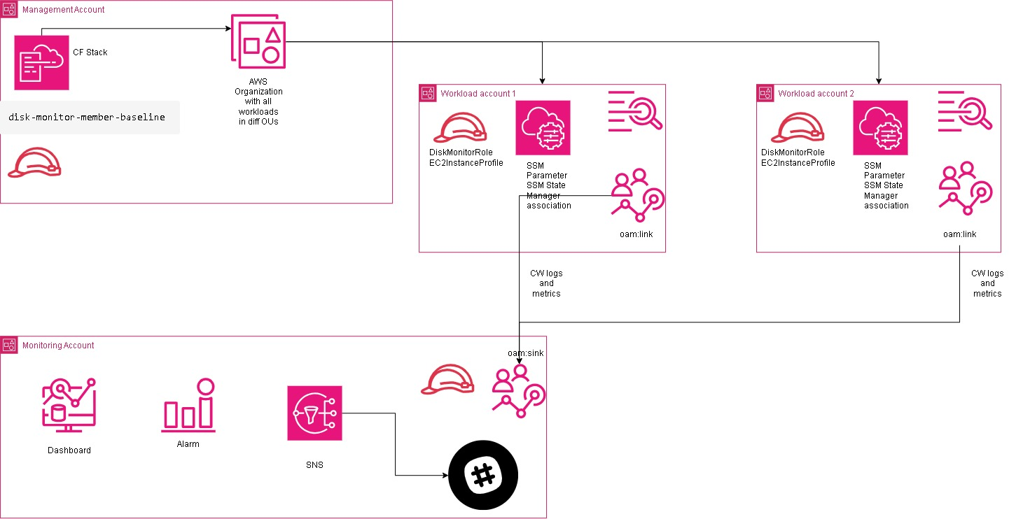
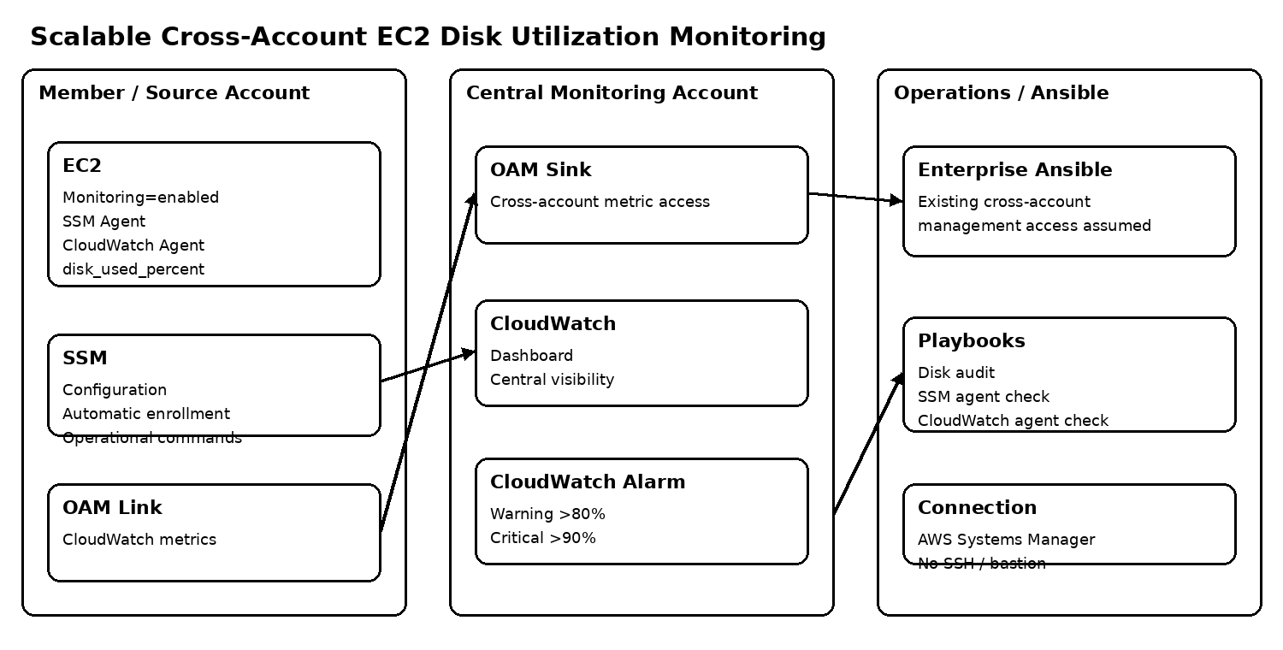
Scope, Assumptions and Constraints
Scope
- EC2 instances
- Multi account discovery
- Cloud watch agent deployment.
- Disk metrics
- Data aggregation
Assumptions
- AWS Organization exists
- Ec2 have cloudwatch agents installed and can reach required endpoints and have instance profiles.
- Ansible will be used only for bootstrapping vms for SSM Agents and initiate disk audit. And all environments have cross account instance/management role.
- The monitoring account is available to host centralized CloudWatch/OAM resources.
- Member accounts can be targeted by the approved CloudFormation StackSet deployment mechanism.
- AWS Systems Manager is the preferred operational connection mechanism; SSH and bastion hosts are not required.
- Application-specific remediation is outside scope.
Constraints / Deliberate Exclusions
- No Lambda-based monitoring logic.
- No SNS, Slack or PagerDuty integration in the final minimal implementation.
- No custom monitoring database or monitoring server.
- No custom metric aggregation service.
- No SSH key-management or bastion infrastructure.

Deployment layer
AWS Organizations serves as the governance boundary.
CloudFormation StackSets deploy standard monitoring resources into every AWS account automatically.
Resources deployed include:
- IAM Roles
- Instance Profiles
- SSM Parameters
- SSM Associations
- OAM Links
Monitoring Layer
EC2 instances publish metrics using:
- SSM Agent
- CloudWatch Agent
Disk utilization metrics are collected every 5 minutes.
Aggregation Layer
Metrics are shared to the Central Monitoring Account using:
- CloudWatch OAM Link
- CloudWatch OAM Sink
Operational Layer
Ansible is not used as the continuous monitoring engine. It complements the AWS-native monitoring path with on-demand operational checks.
- Ad-hoc disk audit using df -hT.
- Validation that the SSM Agent service is active.
- Validation that the CloudWatch Agent service is active.
- Controlled SSM Agent bootstrap on legacy/non-standard hosts where required.
The enterprise Ansible platform is assumed to already have authorized cross-account management access to target member accounts. This is an enterprise prerequisite and is deliberately not represented as a new role in the monitoring/member CloudFormation stacks.

Key Design Decisions
Decision 1: Considered Option
Ansible periodically executes df -h on all servers and stores results centrally.
Challenges
- Not real-time
- Difficult alerting
Selected Option
Use CloudWatch Agent.
Benefits
- Continuous monitoring
- Native dashboards
- Native alarms
- Scalable architecture
Decision 2: Use Systems Manager Instead of SSH
Challenges with SSH
- Key management
- Security group maintenance
- Bastion infrastructure
Selected Option
AWS Systems Manager
Benefits
- No inbound ports
- Centralized management
- Auditable access
- Scales across accounts
Decision 3: StackSets Instead of Ansible for Enrollment
Why
The assignment focuses on scalability.
Benefits
- Automatic deployment
- Drift detection
- Auto enrollment
- Consistent deployment

Access Management
Identity Architecture
Central Monitoring Account
Contains:
- Monitoring administrators
- CloudWatch dashboards
- Alarms
- OAM Sink
Member Accounts
Contain:
- DiskMonitorRole
- EC2DiskMonitorInstanceProfile

VM Discovery and Enrollment
New Account Onboarding
StackSets automatically create the required IAM roles, SSM associations, and OAM link when an account joins AWS Organizations, enabling monitoring.
New Instance Onboarding
Standard AWS Operating Systems
For supported operating systems such as Amazon Linux 2, the instance profile registers the instance with SSM. State Manager then installs the CloudWatch Agent and publishes disk metrics.

Data Collection Strategy

Collection Method
The CloudWatch Agent collects operating system–level disk metrics from each enrolled EC2 instance and publishes them to Amazon CloudWatch.

Metrics Collected
Linux
- disk_used_percent: Percentage of disk space in use for each monitored file system or mount point.
Windows
- LogicalDisk % Free Space: Percentage of available space on each monitored logical disk.

Metric Dimensions
- InstanceId: Identifies the EC2 instance that generated the metric.
- Path: Identifies the monitored mount point or logical disk.
- Filesystem Type: Identifies the underlying file-system type.

Collection Frequency
Metrics are collected every five minutes, providing timely visibility without creating unnecessary monitoring cost or operational overhead.
This interval balances:
- Early detection of capacity risks
- CloudWatch metric-ingestion cost
- Scalability across accounts, Regions, and instances

Data Aggregation and Visualization

Centralized Visibility
CloudWatch cross-account observability links each member account to the CloudWatch OAM sink in the central monitoring account. This provides a consolidated view of disk metrics without duplicating or manually exporting monitoring data.

Dashboard Views
Executive View
- Total number of monitored instances
- Current warning and critical alerts
- Disks with the highest utilization
Operations View
- Disk utilization by instance and mount point
- Regional monitoring view
- Account-level monitoring view
Capacity View
- Historical utilization trends for capacity planning and growth analysis.

Alerting Strategy

Warning Alert
- Threshold: Disk utilization exceeds 80%.
- Notification: Amazon SNS sends alerts to email and Slack channels for investigation.

Critical Alert
- Threshold: Disk utilization exceeds 90%.
- Escalation: Amazon SNS forwards the alert to PagerDuty and the operations team for immediate response.
Security Design
Security Controls
Identity Controls
- IAM Roles
- STS AssumeRole
- Least Privilege
Network Controls
- No SSH required
- No Bastion required
- HTTPS only
Secrets Management
- No credentials stored in GitHub
- Instance Profiles used
Governance Controls
- AWS Organizations
- SCPs
- StackSet Drift Detection

Scalability
Accounts
StackSets automatically deploy monitoring resources to new accounts.

Instances
State Manager installs the CloudWatch Agent on new instances.

Regions
StackSet deployment targets enable additional Regions.

Volume
CloudWatch manages metric storage and retention without additional infrastructure.

